BSCS FINAL PROJECT

FLOWMIND AI



Project Advisor

Sir Shah Nawaz

Presented by:
Group ID: F24SE042

Student Reg# Student Name
L1F21BSSE0500 Hassan Raza
L1F20BSSE0007 Muskan Amjad
L1F21BSSE0570 Muhammad Talha

Faculty of Information Technology

University of Central Punjab

Software Requirements Specification

FLOWMIND AI

Advisor: Sir Shah Nawaz

Group ID: F24SE042
Member Name | Primary Responsibility
Hassan Raza | Documentation and Project plan
Muskan Amjad | Documentation and UML
Muhammad Talha | UML

Table of Contents
Table of Contents i
Revision History ii
Abstract iii
1. Introduction and Background 1
1.1 Product (Problem Statement) 1
1.2 Background 1
1.3 Scope 1
1.4 Objective(s)/Aim(s)/Target(s) 1
1.5 Challenges 1
1.6 Learning Outcomes 1
1.7 Nature of End Product 1
1.8 Completeness Criteria 1
1.9 Business Goals 1
1.10 Related Work/ Literature Survey/ Literature Review 2
1.11 Document Conventions 2
2. Overall Description 3
2.1 Product Features 3
2.2 User Classes and Characteristics 3
2.3 Operating Environment 3
2.4 Design and Implementation Constraints 3
2.5 Assumptions and Dependencies 3
3. Functional Requirements 4
3.1 Name of Use-Case 1 4
3.2 Name of Use-Case 2 (and so on) 4
3.3 Requirements Analysis and Modeling 4
4. Nonfunctional Requirements 5
4.1 Performance Requirements 5
4.2 Safety Requirements 5
4.3 Security Requirements 5
4.4 Additional Software Quality Attributes 5
5. Other Requirements 5
6. Revised Project Plan 5
7. References 6
Appendix A: Glossary 7
Appendix B: IV & V Report 8

Revision History
Name | Date | Reason For Changes | Version

Abstract
The FlowMind AI Diagram Generator is a web and mobile application designed to streamline the creation of system modeling diagrams, including flowcharts, use case diagrams, sequence diagrams, and data flow diagrams (DFDs). The project addresses the significant problem of inefficiency and errors in manual diagram creation, offering a user-friendly and mobile-responsive alternative. Existing tools are either too complex or lack portability, making them unsuitable for users seeking simplicity and accessibility. This tool leverages structured user inputs, such as system details and relationships, to automatically generate diagrams using predefined templates. Unlike other solutions requiring in-depth knowledge or extensive manual effort, FlowMind simplifies the process while allowing basic customization of nodes and connections. The mobile-friendly design ensures accessibility across all devices, supporting on-the-go diagramming. FlowMind combines core knowledge areas like web development, responsive design, and JavaScript-based libraries (e.g., Mermaid.js and D3.js) for rendering dynamic diagrams. It eliminates the need for complex AI processing, focusing instead on lightweight functionality for efficiency. The final product will enable users to create editable diagrams quickly, export them in formats like PNG or PDF, and work seamlessly across platforms. The project aims to save time and reduce errors while maintaining simplicity, making it ideal for small teams, startups, and individual users. FlowMind's results will demonstrate a practical, innovative tool for basic system diagramming, prioritizing usability and accessibility without overcomplicating the process.

Introduction and Background
The FlowMind AI Diagram Generator is an innovative tool designed to address challenges in creating system modeling diagrams such as flowcharts, use case diagrams, sequence diagrams, and data flow diagrams (DFDs). These diagrams are crucial in software development, system analysis, and project management for visualizing processes, system interactions, and data flows. Despite their importance, existing tools are often too complex, time-consuming, or limited in accessibility, especially for users who need lightweight, mobile-friendly solutions.
In the current market, tools like Lucidchart and Draw.io dominate but cater to advanced users, requiring significant manual input or extensive learning. This complexity often hinders productivity for small teams, startups, or individuals who require simpler solutions for basic diagramming tasks. Additionally, the lack of mobile-responsive platforms limits users' ability to work flexibly across devices.
The significance of this problem lies in the inefficiency and errors introduced by manual diagram creation. For users in fast-paced environments, a straightforward and accessible solution is essential. FlowMind addresses this need by leveraging structured user inputs and predefined templates to generate diagrams automatically. This approach ensures ease of use, minimal effort, and reduced dependency on technical expertise.
The motivation behind this project stems from the growing demand for intuitive, time-saving tools in software and system design. By simplifying diagram creation and enabling mobile compatibility, FlowMind aims to empower users with a lightweight, efficient, and accessible solution for their modeling needs.

Product (Problem Statement)
It is quite difficult and time-consuming process to convert functional requirements into UML diagrams. The FlowMind AI Diagram Generator is a web and mobile application that simplifies the creation of essential system modeling diagrams such as flowcharts, use case diagrams, sequence diagrams, and data flow diagrams (DFDs). The tool addresses the challenges of manual diagram creation, which is often time-consuming, prone to errors, and inaccessible on mobile devices. FlowMind provides a solution by allowing users to input structured details through an intuitive form. It generates diagrams automatically using predefined templates, minimizing effort and complexity. The application focuses on user-friendliness, mobile responsiveness, and lightweight functionality, making it an ideal tool for small teams, startups, and individual users seeking an efficient diagramming solution without the need for extensive technical expertise or complex software.

Background
The domain of system modeling focuses on visually representing processes, systems, and their interactions to facilitate analysis, design, and communication among stakeholders. These visual tools, such as flowcharts, use case diagrams, sequence diagrams, and data flow diagrams (DFDs), are integral to software development, system engineering, and business process management.
Traditional diagramming tools require manual creation, which can be tedious, time-consuming, and prone to human error. Existing solutions like Lucidchart and Visio often cater to advanced users with complex features, making them inaccessible or overwhelming for individuals and small teams with basic needs. Furthermore, many of these tools are not optimized for mobile usage, limiting their flexibility in modern, fast-paced environments.
The rise of responsive and AI-driven technologies has paved the way for smarter and more accessible solutions. Leveraging this trend, FlowMind simplifies the diagramming process by automating diagram generation using structured user inputs. This approach bridges the gap between technical sophistication and ease of use, making system modeling more accessible to non-technical users while maintaining efficiency and accuracy.

Scope
The FlowMind AI Diagram Generator is designed to streamline the creation of system modeling diagrams by automating the process and offering a user-friendly, responsive platform. The product caters to individuals, small teams, and organizations that require basic system diagrams for software development, system analysis, and business process management.
The core functionalities include:
- Diagram Creation: Automatic generation of flowcharts, use case diagrams, sequence diagrams, and DFDs based on user-provided inputs.
- Customizability: Basic editing capabilities, such as modifying node labels, shapes, and connections, to meet specific user needs.
- Cross-Platform Accessibility: A mobile-responsive design ensures seamless usability across web and mobile devices.
- Export Options: Diagrams can be exported in multiple formats, including PNG and PDF, for integration into reports and presentations.
- Predefined Templates: Users can choose from a range of templates to simplify and accelerate the diagramming process.
The project focuses on providing a lightweight, efficient tool for generating basic diagrams, excluding complex AI-driven analysis or high-end features typically found in enterprise-level tools. FlowMind prioritizes accessibility, ease of use, and flexibility, making it ideal for quick, straightforward diagramming tasks.

Objective(s)/Aim(s)/Target(s)
- Simplify Diagram Creation: Provide an intuitive platform for automatically generating system modeling diagrams such as flowcharts, use case diagrams, sequence diagrams, and DFDs using user inputs.
- Enhance Accessibility: Develop a mobile-responsive web application to enable users to create and edit diagrams across devices, ensuring flexibility and ease of use.
- Increase Efficiency: Reduce the time and effort required for manual diagram creation through predefined templates and automated generation processes.
- Support Basic Customization: Allow users to edit and customize generated diagrams, including modifying node labels, shapes, and connections, to suit specific needs.
- Enable Export Functionality: Facilitate exporting diagrams in formats like PNG and PDF for seamless integration into documents, presentations, and reports.
- Provide a Lightweight Tool: Focus on delivering a simple, lightweight solution tailored to individual users, startups, and small teams rather than enterprise-scale complexity.
- Ensure User-Friendliness: Design an intuitive user interface to accommodate users with minimal technical expertise while maintaining functionality.

Challenges
- Simplification vs. Functionality: Striking the right balance between simplifying the diagramming process and maintaining essential functionality for customization and flexibility. Ensuring the tool remains user-friendly without sacrificing the ability to create useful, tailored diagrams.
- Mobile Responsiveness: Developing a platform that is fully functional across various devices, including mobile phones and tablets, while maintaining the integrity of the diagrams and user interface.
- User Input Validation: Ensuring that user inputs are structured correctly to generate accurate diagrams. Designing a robust system to handle various input types and ensuring that the system adapts well to different user data without errors.
- Performance Optimization: Managing the performance of the application, especially for generating complex diagrams, while keeping the tool lightweight and responsive, particularly on mobile devices.
- Limited Customization: Providing enough customization options for users to modify diagrams according to their needs without overwhelming them with too many choices or a steep learning curve.
- Integration with Export Features: Ensuring the diagrams can be easily exported in different formats (e.g., PNG, PDF) without losing quality or functionality.
- Cross-Platform Compatibility: Developing and testing the tool to work consistently across different browsers, devices, and operating systems, ensuring a seamless experience for all users.
- User Adoption: Encouraging users to switch from more complex, feature-rich diagramming tools by demonstrating the efficiency, simplicity, and mobile-friendly advantages of the FlowMind tool.

Learning Outcomes
After completion of this project we are confident that we will be able in developing comprehensive skills in software and web development, including proficiency in system diagramming, mobile-responsive design, user interface design, system integration, performance optimization, data handling, and project management, while fostering problem-solving abilities to create functional and accessible applications.

Nature of End Product
The end product, FlowMind AI Diagram Generator, is a web and mobile application designed to automate and simplify the creation of basic system modeling diagrams, such as flowcharts, use case diagrams, sequence diagrams, and data flow diagrams (DFDs). The tool is lightweight, intuitive, and mobile-responsive, making it accessible to both technical and non-technical users.
Key characteristics of the end product include:
- User-Friendly Interface: An easy-to-use platform where users can quickly input structured data (such as system entities, actors, and relationships) to automatically generate diagrams.
- Predefined Templates: A set of predefined templates for each diagram type that automates the diagram creation process, minimizing manual work.
- Mobile-Responsive: A fully responsive design that ensures users can create, edit, and view diagrams seamlessly across different devices, including smartphones and tablets.
- Customization Options: Basic diagram customization options allowing users to modify nodes, labels, shapes, and connections as needed.
- Export Functionality: The ability to export diagrams in multiple formats, such as PNG and PDF, for easy sharing and integration into reports or presentations.
- Lightweight and Efficient: The application focuses on speed, simplicity, and efficiency, making it ideal for small teams, startups, or individual users who require quick, straightforward diagramming without unnecessary complexity.
- Cross-Platform Compatibility: A web-based application that works across different browsers and platforms, providing a consistent experience for all users.
FlowMind AI Diagram Generator is designed to be a practical, lightweight, and highly accessible tool that simplifies diagram creation for everyday use.

Completeness Criteria

The project will be considered complete when the following criteria are met:

1. Full Functionality: The application must successfully generate all four types of system diagrams (flowcharts, use case diagrams, sequence diagrams, and DFDs) based on structured user inputs (25%).

2. User Input Validation: The tool must handle and validate user inputs effectively, ensuring that diagrams are generated accurately based on the data provided (10%).

3. Responsive Design: The application must be fully responsive and functional across different devices (desktop, tablet, and mobile) and browsers, ensuring smooth interaction for all users. (10%)

4. Customization Capabilities: Users must be able to edit and customize diagrams, including adjusting nodes, labels, shapes, and connections after generation (5%).

5. Export Functionality: The system must allow users to export generated diagrams in high-quality formats (PNG and PDF) without loss of data integrity (5%).

6. Usability: The user interface must be intuitive, with minimal learning curve, ensuring that users (even those without technical knowledge) can easily navigate and use the tool (5%).

7. Performance: The application should perform efficiently with minimal loading times for generating and rendering diagrams, especially on mobile devices (5%).

8. Cross-Platform Compatibility: The web application should work consistently across various browsers and operating systems without issues (5%).

9. Testing and Bug-Free: The application must be thoroughly tested for bugs, errors, and edge cases, ensuring smooth functionality in all scenarios (20%).

10. Documentation: Proper user documentation should be provided, detailing the use of the application, how to input data, customize diagrams, and export them. Additionally, the code should be well-documented for future maintenance and updates (10%).

Business Goals
The FlowMind AI Diagram Generator addresses the following business goals:
- Streamlining the diagram creation process, reducing the time and effort for users, especially small teams and startups, to create system modeling diagrams.
- Enhancing productivity and efficiency by providing a simple and accessible tool that requires minimal technical knowledge.
- Offering a mobile-responsive platform, enabling users to work on diagrams across multiple devices, ensuring flexibility and accessibility.
- Providing export functionality in various formats (PNG, PDF), allowing users to easily share diagrams for integration into reports, presentations, and documentation.
- Offering a lightweight and cost-effective diagramming solution for users who do not require advanced features, making it suitable for everyday use.
- Creating a niche in the market by appealing to users looking for an easy-to-use, mobile-friendly, and efficient diagramming tool without the complexity of enterprise-level software.
- Supporting future growth and scalability, allowing for potential updates and feature expansions based on user feedback and market demands.

Related Work/ Literature Survey/ Literature Review
In the domain of system diagramming \tools, several existing solutions provide varying levels of functionality and complexity. Tools such as Lucidchart, Microsoft Visio, and Draw.io are widely used for creating system modeling diagrams. These platforms offer a broad range of diagram types, including flowcharts, use case diagrams, sequence diagrams, and DFDs. However, they are often laden with features that may overwhelm novice users and require significant manual input to create diagrams. While these tools are versatile, they are not optimized for users who need a lightweight, simple, and mobile-friendly solution.
Lucidchart is one of the most popular diagramming tools, offering cloud-based collaboration and an extensive library of templates. However, its feature set is often too complex for users who only need basic diagrams. Additionally, it requires a subscription for access to advanced features and its mobile application is less intuitive, limiting its appeal for users seeking simplicity.
Draw.io (also known as diagrams.net) :is another widely used tool, offering a free, web-based diagramming platform with a variety of templates. While it is more lightweight compared to Lucidchart: It still presents users with an array of customization options, which may be overwhelming for users looking for a simple, easy-to-use platform for quick diagram generation.
Microsoft Visio : A traditional diagramming software, is known for its powerful capabilities in creating detailed diagrams. However, it is primarily designed for professional use and requires a steep learning curve. It lacks a strong mobile interface and tends to be inaccessible to casual or mobile-only users, making it less ideal for those who need a responsive, on-the-go solution.
While these tools are highly capable, they often present barriers to entry for individuals or small teams seeking simple diagramming solutions. They either lack mobile responsiveness, are too complex for non-technical users, or are expensive to access fully.
FlowMind aims to address these limitations by offering a simplified, user-friendly platform that generates system diagrams automatically from structured inputs. By focusing on ease of use, mobile accessibility, and efficiency, FlowMind provides a solution that reduces the need for extensive manual diagramming, enabling users to focus on their core tasks rather than spending time learning complex diagramming tools.
This literature survey highlights the gap in the market for a lightweight, mobile-friendly diagramming tool and positions FlowMind as a much-needed alternative for small teams, startups, and individual users who require an efficient, accessible solution for basic system diagramming needs.

Document Conventions
This SRS document adheres to standard typographical conventions, including the use of headings for section titles and bullet points for lists. The writing style utilizes Times New Roman font, with nouns emphasized in italic. The paragraph font size is set to 12px, headings are styled at 18px, and subheadings at 14px.

Overall Description

Product Features
The FlowMind AI Diagram Generator includes the following major features:
- Diagram Creation: The core feature of the tool is the automatic generation of system modeling diagrams based on structured user inputs. Users can create four types of diagrams: flowcharts, use case diagrams, sequence diagrams, and data flow diagrams (DFDs).
- Customizable Diagrams: Once a diagram is generated, users have the ability to modify elements, such as labels, nodes, shapes, and connections, allowing for basic diagram customization.
- Mobile-Responsive Interface: The application is designed to be fully responsive, ensuring that users can create and edit diagrams seamlessly across different devices, including smartphones, tablets, and desktops.
- Predefined Templates: The tool offers predefined templates for each diagram type, streamlining the diagram creation process and making it easier for users to get started with minimal input.
- Export Functionality: After creating and customizing diagrams, users can export their work in popular formats like PNG and PDF for easy sharing, integration into reports, and use in presentations.
- Simple User Interface: The interface is designed to be intuitive and user-friendly, enabling both technical and non-technical users to navigate and use the tool effectively without requiring a steep learning curve.
- Cross-Platform Compatibility: The tool is accessible via all major web browsers, ensuring compatibility across different operating systems, enhancing flexibility for users in diverse environments.
These high-level features provide users with a simple, efficient, and mobile-friendly solution for creating basic system diagrams with minimal effort. Detailed descriptions and specifications of these features will be provided in Section 3.

User Classes and Characteristics
The FlowMind AI Diagram Generator is designed to cater to several user classes, each with distinct characteristics and usage patterns. These user classes can be differentiated based on their frequency of use, technical expertise, and the scope of functions they require. The main user classes are as follows:
- Casual/Occasional Users
  - Characteristics: Typically non-technical users with minimal diagramming experience. They require simple and fast tools to create basic diagrams for personal use or small projects.
  - Needs: These users need an intuitive, easy-to-use interface with minimal customization options. They will use the tool occasionally for straightforward tasks, such as creating flowcharts or diagrams for school projects or small presentations.
  - Key Requirements:
    - User-friendly interface
    - Basic diagram creation (flowcharts, use case diagrams, etc.)
    - Simple customization options
    - Mobile-responsive design for quick on-the-go use
- Small Teams/Startups
  - Characteristics: Small teams with limited resources who need to create system diagrams for internal documentation, presentations, or planning. They may include individuals with varying technical expertise.
  - Needs: These users require a simple yet flexible diagramming tool to quickly generate and modify diagrams. They will use the tool frequently to communicate ideas visually within the team.
  - Key Requirements:
    - Predefined templates for quick creation
    - Basic customization and collaboration features
    - Export functionality (PNG, PDF)
    - Cross-platform compatibility for use across devices
    - Mobile responsiveness for working on the go
- Educational Users/Students
  - Characteristics: Students or learners who need to create diagrams for academic purposes, such as assignments or reports. They may have limited technical knowledge but need a tool that simplifies diagramming tasks.
  - Needs: These users need a straightforward, cost-effective solution for generating diagrams. They will primarily use the tool to create flowcharts, DFDs, and use case diagrams for academic projects.
  - Key Requirements:
    - Easy-to-use interface with step-by-step guidance
    - Quick generation of basic diagram types
    - Export options for academic presentations and reports
    - Mobile-friendly for working on assignments from various locations
- Advanced Users/Tech Enthusiasts
  - Characteristics: Users with more technical expertise who may require additional flexibility or customization in their diagrams. They might include developers, system architects, or business analysts who have some knowledge of diagramming standards.
  - Needs: These users might use the tool more frequently and may require more advanced features, such as additional customization or integration with other systems. However, they still prefer a lightweight solution without the complexity of enterprise-grade tools.
  - Key Requirements:
    - Flexible customization options for diagramming
    - Advanced editing and node adjustments
    - Integration with other tools (if applicable)
    - Cross-platform support and desktop accessibility
    - Higher-quality export options
- Administrators (if applicable)
  - Characteristics: Users with privileged access to manage the tool’s settings, user permissions, or backend features (if applicable). This class might be relevant if the software is extended with user management or access control features.
  - Needs: Administrators need access to settings that govern the app’s configuration, user access, and security.
  - Key Requirements:
    - User management and access control
    - Advanced system settings and data handling features
    - Secure login and activity monitoring (if required)

Key User Classes to Satisfy
The Casual/Occasional Users and Small Teams/Startups are the favored user classes. These groups are likely to be the largest and most frequent users of the tool, as they require a straightforward, efficient solution for diagramming. These users will benefit most from the product’s simplicity and mobile responsiveness.
While the Advanced Users/Tech Enthusiasts will be important for providing feedback and testing the tool's flexibility, their needs will be secondary to the core simplicity and user-friendliness aimed at the casual users. The Educational Users/Students will also be a significant user class, though their needs will largely align with the casual users in terms of ease of use and affordability.

Operating Environment
The FlowMind AI Diagram Generator is a web-based application that operates in the following environment:
- Hardware Platform:
  - The software is designed to run on general-purpose hardware capable of supporting web browsers. This includes:
    - Desktop Computers: PCs and Macs with moderate processing power.
    - Mobile Devices: Smartphones and tablets (both Android and iOS) with internet connectivity.
    - Minimum Hardware Requirements:
      - RAM: 2GB or higher
      - Processor: 1.2 GHz or faster
      - Screen resolution: 1024x768 or higher
- Operating System:
  - As a web application, FlowMind is compatible with multiple operating systems that support modern web browsers. The software is designed to be cross-platform and will work on:
    - Windows (Windows 7 or later)
    - macOS (macOS 10.10 or later)
    - Linux (latest versions of popular distributions like Ubuntu or Fedora)
    - Mobile Operating Systems:
      - Android (version 5.0 or later)
      - iOS (version 11.0 or later)
- Web Browsers:
  - The application is compatible with the most commonly used modern web browsers:
    - Google Chrome (latest stable version)
    - Mozilla Firefox (latest stable version)
    - Safari (latest stable version)
    - Microsoft Edge (latest stable version)
  - The application will be tested for compatibility with these browsers, and users are encouraged to keep their browsers up-to-date to ensure optimal performance.
- Software Components and Technologies:
  - Frontend: The web interface will be built using HTML5, CSS3, and JavaScript (with React.js or vanilla JS for dynamic content). Diagrams will be rendered using libraries such as Mermaid.js and D3.js for generating visual representations of the system models.
  - Backend (if applicable): If the application requires backend integration (e.g., for saving user data or handling API requests), Node.js will be used for building the backend services.
  - Web Server: The application will run on a cloud-based server (e.g., AWS, Azure, or similar platforms) for scalability and reliability, or it could use traditional hosting platforms.
  - Database: If the tool involves saving user data or diagram templates, a lightweight database like SQLite or MongoDB might be used.
- Internet and Network Requirements:
  - Since the application is web-based, an internet connection is required for accessing the tool. The minimum network speed for smooth usage is 2 Mbps for both uploading and downloading content.
- Mobile Support:
  - Mobile Browsers: The tool will be optimized for mobile browsers on both Android and iOS devices, ensuring that users can access and create diagrams on-the-go.
  - Responsive Design: The application will use CSS Grid and Flexbox layouts to ensure it adapts to various screen sizes, making it fully mobile-responsive.
FlowMind AI Diagram Generator ensures a broad range of accessibility while maintaining efficient performance across all devices and operating systems.

Design and Implementation Constraints
The FlowMind AI Diagram Generator will face several constraints during its design and implementation, which will guide the choices made by the developers. These constraints include:
- Technological Constraints:
  - The application must be developed as a web-based tool, making it compatible across multiple browsers and devices, which limits the use of certain desktop-based technologies.
  - Frontend technologies such as HTML5, CSS3, and JavaScript will be used for creating the user interface. Libraries like React.js, Mermaid.js, and D3.js are selected to handle dynamic content and diagram rendering.
  - For the backend (if required), Node.js will be used, ensuring a lightweight, scalable solution. The use of other backend technologies is constrained by the goal of maintaining simplicity and reducing overhead.
- Cross-Platform Compatibility:
  - The application must be compatible with Windows, macOS, Linux, and mobile platforms (Android and iOS). The need for consistent behavior across these platforms means the developers must adhere to web standards that are supported by modern browsers, which might limit the use of platform-specific features.
  - Mobile responsiveness must be ensured using CSS Flexbox and CSS Grid, which places restrictions on the layout design and requires careful planning to ensure consistent performance across devices of various screen sizes.
- Performance and Resource Constraints:
  - As a web-based tool, performance optimization is critical, particularly for rendering diagrams in real-time. The application must be lightweight to work efficiently on devices with varying hardware capabilities, especially mobile phones with limited processing power and memory.
  - Memory management will be a key focus to ensure smooth operations, especially when handling large or complex diagrams.
  - The tool should not require high bandwidth or extensive system resources, limiting its use of heavy backend processes or large file handling unless absolutely necessary.
- Export Functionality:
  - The ability to export diagrams in PNG and PDF formats must be supported. This feature will be constrained by the compatibility of the JavaScript libraries used for rendering diagrams (e.g., Mermaid.js or D3.js) and their ability to export or generate these formats without significant performance degradation.
- Security and Privacy Considerations:
  - User data protection: If the application allows users to save or share their diagrams, appropriate security protocols must be in place to protect user-generated data. While minimal data will be stored, secure authentication, encrypted communications (via HTTPS), and possibly data anonymization are necessary to protect user privacy.
  - The tool will follow general best practices for web security, including input validation and protection against common attacks (e.g., XSS and SQL injection) if the backend involves a database.
- External Libraries and Dependencies:
  - The use of external libraries such as Mermaid.js for diagram rendering limits certain customizations and features. Developers will need to work within the constraints of these libraries while ensuring they meet the functional requirements of the project.
  - Integration with external tools (e.g., cloud storage for saving/exporting files) is constrained by the available API features and compatibility with the selected backend technologies.
- User Interface Design Constraints:
  - The user interface design must be simple and intuitive, catering to a wide range of user expertise. The interface should avoid overwhelming users with too many customization options while still providing essential functionality, such as diagram editing and exporting.
  - The design must be responsive and optimized for mobile devices, which may limit the amount of content displayed on smaller screens and necessitate careful consideration of layout elements.
- Regulatory and Compliance Constraints:
  - If the application is used in specific regulated industries (e.g., healthcare, finance), developers must ensure compliance with relevant data protection regulations (such as GDPR or CCPA) if personal data is involved.
  - There are no immediate regulatory constraints for general use, but any future expansion or integration may require adherence to industry-specific standards.
- Maintenance and Extensibility:
  - The application must be designed in a way that allows for easy maintenance and updates. Developers will need to follow clean coding practices and ensure modularity, especially if the tool is extended with additional features in the future.
  - The codebase should be well-documented to ensure that the development team or future maintainers can understand and update the system as needed.
the FlowMind AI Diagram Generator, ensuring that the application remains functional, secure, and user-friendly while meeting the project goals.

Assumptions and Dependencies
The development of the FlowMind AI Diagram Generator is based on several assumptions and dependencies that may impact the project. These include assumptions about the operating environment, technologies, and third-party components, as well as external factors that could affect the project. The following outlines the key assumptions and dependencies:

Assumptions
- Availability of Web Browsers:
It is assumed that users will have access to modern web browsers such as Google Chrome, Mozilla Firefox, Safari, and Microsoft Edge that support the technologies required for the application, including HTML5, CSS3, and JavaScript.
- Stable Internet Connection:
Since FlowMind is a web-based application, it is assumed that users will have a stable internet connection for accessing the tool and using its features, especially for exporting diagrams and saving them online.
- Cross-Platform Compatibility:
It is assumed that the application will run smoothly across various platforms (Windows, macOS, Linux) and mobile devices (iOS and Android) using modern browsers. Compatibility issues with older versions of operating systems or browsers may be outside the scope of the project.
- Mobile Devices with Sufficient Resources:
The application assumes that mobile devices (smartphones and tablets) used to access the tool will have adequate processing power, memory, and screen resolution to handle the diagramming functions smoothly.
- Minimal Data Storage Requirements:
The tool is not expected to require large-scale data storage. User data will be minimal, and there will be no heavy processing or storage of sensitive information. The assumption is that users will primarily work with locally-generated diagrams, with occasional export functionality.
- Usage of Predefined Libraries:
The project assumes the availability and continued support of third-party libraries and frameworks such as Mermaid.js, D3.js, React.js, and Node.js. Any major changes or lack of support from these libraries could affect the functionality and timeline of the project.
- No Complex AI Integration:
The project assumes that AI-driven natural language processing (NLP) or other advanced AI features will not be integrated, as the tool is focused on predefined templates and user-inputted data. If the scope changes to include complex AI, this assumption would need to be revised.
- User Interface Simplicity:
It is assumed that the user interface will remain simple and intuitive, requiring minimal guidance for non-technical users. Any additional complexity in the user interface (e.g., advanced customization or multiple diagram features) may increase the development time and complexity.
- No External System Integrations:
It is assumed that the tool will not integrate with external systems (e.g., project management tools or cloud services) during its initial release. Future versions of the tool may have these capabilities, but they are not part of the current scope.

Dependencies
- Third-Party Libraries:
  - The tool relies heavily on third-party JavaScript libraries, particularly Mermaid.js and D3.js, for diagram rendering. These libraries must support the required features and be maintained throughout the project’s lifecycle. Any changes to these libraries could impact functionality.
  - The project also depends on React.js for frontend development and Node.js for any backend integration, if applicable. The continued support and compatibility of these technologies are critical to the project's success.
- Cloud Hosting:
The application will be hosted on a cloud platform (e.g., AWS, Azure, or Google Cloud). The availability and reliability of the cloud hosting service will impact the performance and uptime of the application.
- Browser and OS Updates:
The performance and compatibility of the application depend on the continued support of modern browsers and operating systems. Major updates or changes to these platforms, especially related to web standards, could affect the application’s functionality.
- Exporting Libraries:
The ability to export diagrams in formats like PNG and PDF depends on the functionality offered by the libraries and tools used for rendering and exporting. If these libraries do not support seamless export functionality, the project may face challenges in meeting this requirement.
- Regulatory and Compliance Factors:
If the project expands to handle sensitive or regulated data in the future (e.g., in healthcare or finance), it will depend on external regulatory requirements such as GDPR, CCPA, or HIPAA. These external compliance factors would influence the development of features related to data security and user privacy.
- User Adoption:
The success of the tool will depend on user adoption and feedback. It is assumed that users will find the tool valuable and easy to use. A lack of adoption or poor user feedback could result in changes to the development approach, features, or user interface design.

Functional Requirements

Use Case Diagram:

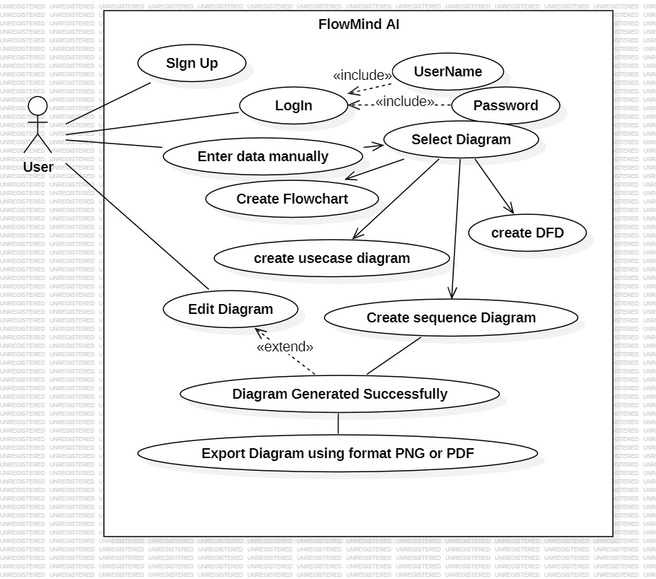

Name of Use-Case 1
Identifier |  | Flowmind AI
Purpose |  | To create and edit various types of diagrams (flowcharts, DFDs, use case diagrams, and sequence diagrams) based on user-provided data
Priority |  | High
Pre-conditions |  | • User has access to the Flowmind AI tool.  • User has basic knowledge of diagram types and their elements.
Post-conditions |  | • Desired diagram is created or edited successfully.  • Diagram is exported in the desired format (PNG or PDF).
Typical Course of Action
S# | Actor Action |  | System Response
1 | Enter data manually |  | System displays options to select diagram type.
2 | Select diagram type (flowchart, DFD, use case diagram, sequence diagram)
3 | Enter data for selected diagram type
4 | Edit diagram |  | System allows user to modify elements of the diagram
5 | Export Diagram |  | System exports the diagram in the specified format (PNG or PDF)
Alternate Course of Action
S# | Actor Action |  | System Response
1
2
3
…

Requirements Analysis and Modeling

ERD Diagram:

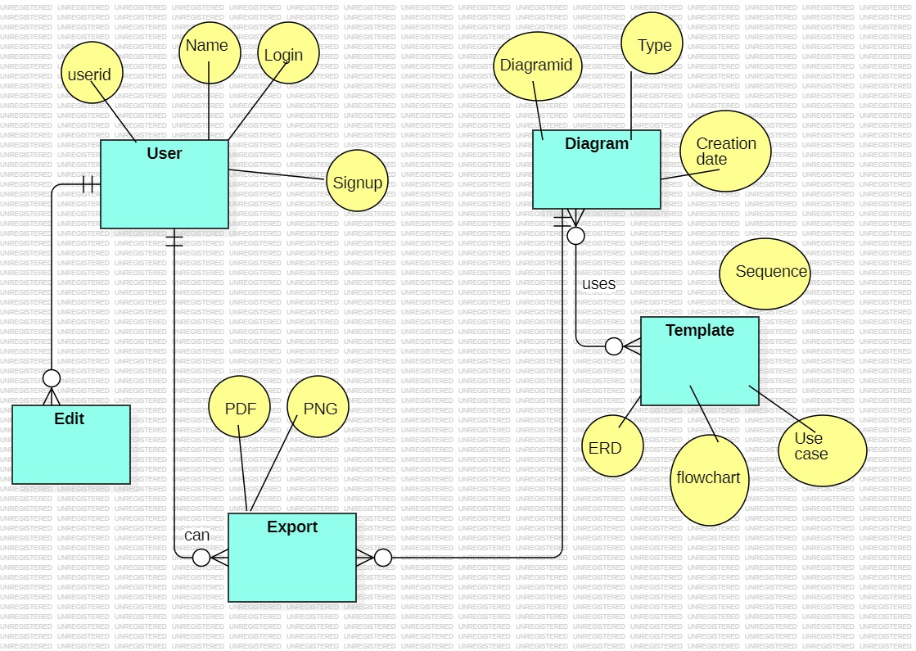

Abstract Class Diagram:

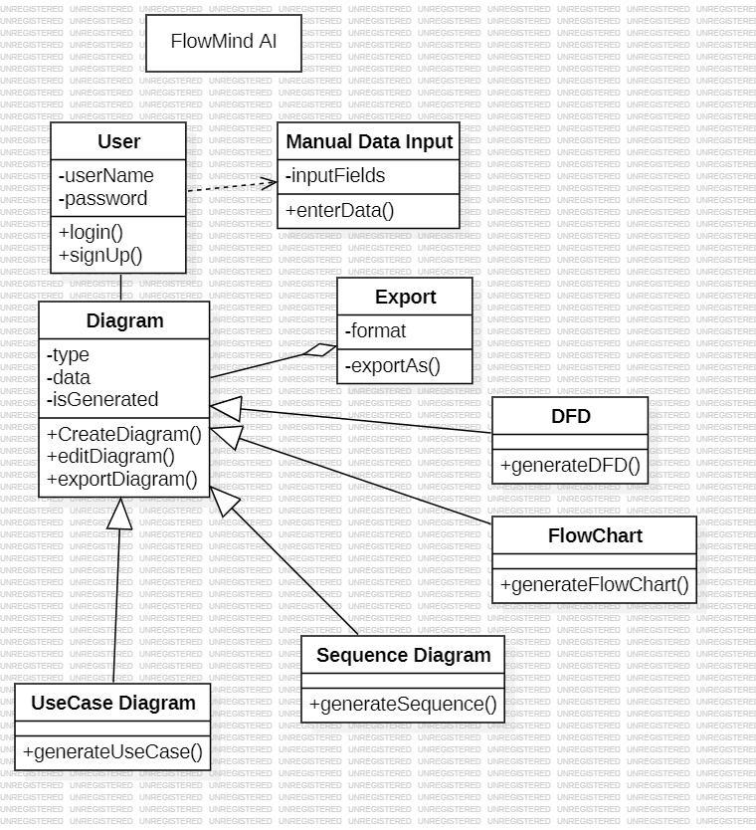

Sequence Diagram:

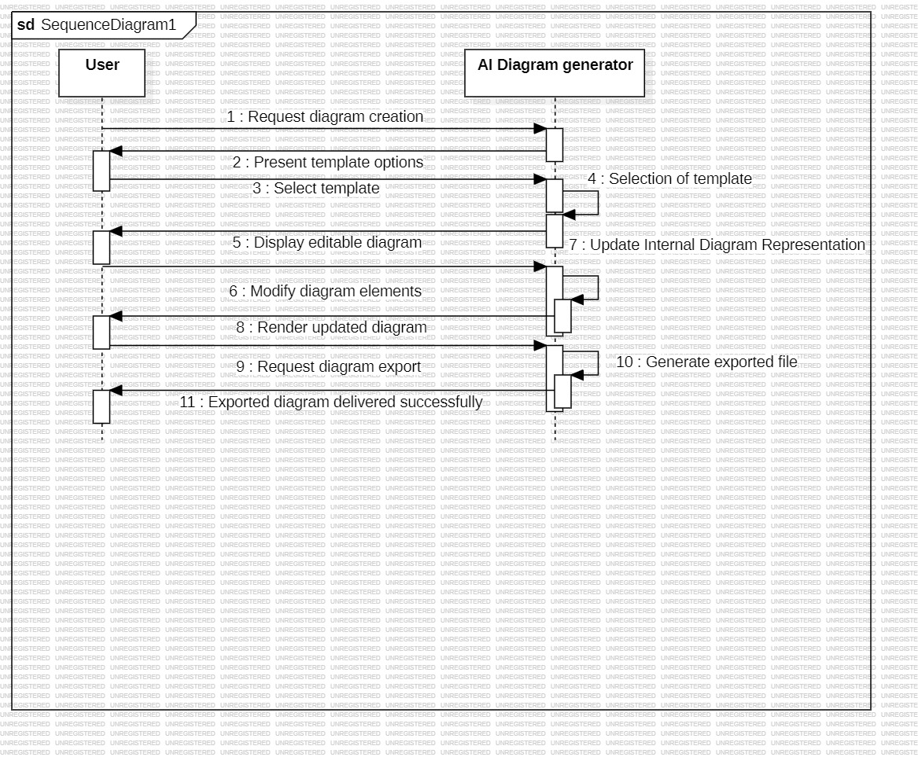

Nonfunctional Requirements

Performance Requirements
The FlowMind AI Diagram Generator must meet specific performance requirements to ensure a smooth user experience, especially when generating and modifying diagrams:
- Diagram Generation Speed: The system should generate diagrams within 5 seconds for basic diagrams (flowcharts, use case diagrams, etc.) and within 10 seconds for more complex diagrams (sequence diagrams or DFDs) based on typical user input.
  - Rationale: Quick diagram generation is essential for maintaining user engagement and efficiency. Users should not experience long delays when creating or modifying diagrams.
- Responsiveness: The web application should have a responsive interface that adapts seamlessly across devices. Mobile devices with slower internet connections or older hardware should not experience significant delays in rendering or editing diagrams.
  - Rationale: Ensuring the tool works efficiently on a wide range of devices is crucial, especially since mobile responsiveness is a key feature.
- Simultaneous User Load: The system should be able to handle at least 100 simultaneous users (in case of shared usage or cloud access) without performance degradation.
  - Rationale: Since the tool may be used by small teams or educational users working concurrently, the system must be robust enough to handle moderate traffic without performance issues.
- Export Functionality: Export times for PNG/PDF files should not exceed 5 seconds per file generation. Larger or more detailed diagrams may take longer but should still be optimized for quick export.
  - Rationale: Users expect to export diagrams promptly for further use in reports or presentations.

Safety Requirements
Safety requirements for the FlowMind AI Diagram Generator will primarily address data integrity and user interaction with the tool:
- Data Loss Prevention:
  - The system must include autosave functionality, ensuring that user-generated diagrams are saved every 2 minutes. This helps prevent data loss in case of browser crashes or session timeouts.
  - Rationale: Users should not lose their work due to unexpected system failures.
- Browser and Device Compatibility:
  - The application should be compatible with the latest stable versions of web browsers (e.g., Google Chrome, Mozilla Firefox, Safari) and mobile operating systems (iOS, Android). It must not cause browser crashes or freeze user devices.
  - Rationale: Ensuring safety from technical failures, such as crashes, is important for user trust and satisfaction.
- Safety in User Interaction:
  - The tool must prevent the unintentional deletion or corruption of diagrams. Users should receive a confirmation prompt for actions like deleting or resetting a diagram to avoid accidental data loss.
  - Rationale: Preventing unintended user actions reduces the risk of harm to the user's data and ensures a safer user experience.

Security Requirements
FlowMind AI Diagram Generator, the following security measures must be in place:
- User Authentication:
  - Users must authenticate with email and password before accessing features such as saving or exporting diagrams (if user accounts are implemented). Passwords must be hashed using strong hashing algorithms (e.g., bcrypt).
  - Rationale: To prevent unauthorized access to user data and ensure the integrity of user-created diagrams.
- Data Protection:
  - Any user data, including saved diagrams, must be encrypted using SSL/TLS protocols during transmission to protect privacy and confidentiality. If stored on a server, data should be encrypted at rest.
  - Rationale: Protecting user-generated content from unauthorized access ensures the security and privacy of personal or professional work.
- Access Control:
  - Only authenticated users should have access to their own diagrams and account settings.
  - Rationale: User data must be segregated to ensure that no unauthorized users can access or manipulate another user’s data.
- Compliance with Regulations:
  - If the tool is to be used in industries that require compliance (e.g., GDPR, CCPA), the system must ensure that user data is stored and processed according to relevant data protection regulations.
  - Rationale: Compliance with international and industry-specific security and privacy regulations ensures that the system can be safely adopted by a broad range of users.

Additional Software Quality Attributes
The following quality attributes are important for the FlowMind AI Diagram Generator:
- Usability:
  - The system should provide an intuitive interface with minimal learning curves. The tool should be usable by both technical and non-technical users, with features like tooltips and step-by-step guidance.
  - Rationale: Ensuring ease of use is a key factor for attracting and retaining a broad user base, especially those with limited diagramming experience.
- Reliability:
  - The application must be 99.9% reliable in terms of uptime, meaning it should be operational without errors for 99.9% of the time during normal usage.
  - Rationale: Users rely on the tool for their work, so downtime or system errors must be minimized to maintain trust and usability.
- Portability:
  - The tool should be compatible with major operating systems (Windows, macOS, Linux) and should function across mobile and desktop browsers.
  - Rationale: Cross-platform portability ensures that users can access the tool on any device, improving flexibility and usability.
- Maintainability:
  - The system should be designed with clean, well-documented code that is easy to maintain and extend with future features.
  - Rationale: Good maintainability ensures that the product can evolve as user needs change and allows for the timely fixing of bugs or security vulnerabilities.
- Flexibility:
  - The application should allow users to easily switch between diagram types (e.g., from a flowchart to a use case diagram) with minimal friction.
  - Rationale: Flexibility in diagram creation and modification will help users adjust their work according to changing needs.
- Testability:
  - The system must be designed to support automated testing, particularly for key functionalities like diagram generation, saving, and exporting. Tests should be automated for both the front-end interface and back-end processes.
  - Rationale: Ensuring that the software can be easily tested will improve reliability, reduce bugs, and speed up development.
FlowMind AI Diagram Generator meets user expectations and provides a robust, secure, and efficient experience.

Other Requirements
The following additional requirements must be considered for the FlowMind AI Diagram Generator project. These cover areas such as database, external interfaces, legal concerns, and internationalization:
Database Requirements
- Database Storage:
If the tool includes user accounts or saves diagrams for later access, a database will be required to store user data and diagrams. The database should be relational (e.g., MySQL or PostgreSQL) or NoSQL (e.g., MongoDB) depending on the system's scalability and structure.
  - Requirements:
    - The database must store user account information, diagrams, and metadata securely.
    - Diagrams should be linked to the user’s account for future retrieval.
    - Data must be encrypted both at rest and during transmission.
  - Backup and Recovery:
    - The system must implement regular backups to ensure data integrity and protection from loss.
External Interface Requirements
- Software Interfaces:
  - Diagram Generation Libraries: The tool depends on third-party JavaScript libraries like Mermaid.js, D3.js, and React.js for generating, rendering, and displaying diagrams. These libraries should be up-to-date and maintained to ensure proper integration.
  - Export Options: The system must generate diagrams in PNG and PDF formats. It will rely on libraries (e.g., jsPDF or html2canvas) to facilitate diagram export.
- External Services:
If applicable, the tool may integrate with cloud storage services for saving diagrams. These services could include Google Drive, Dropbox, or other cloud providers for easy storage and sharing of exported diagrams. Integration with these services should be via secure APIs and user authentication.
- Hardware Interfaces:
  - The application will not directly interact with any hardware. However, it should function optimally on various hardware configurations (e.g., low-spec smartphones, tablets, desktops) without requiring high-end devices for functionality.
  - Minimum Hardware Requirements: Devices should have 2GB RAM or more and a 1.2 GHz processor for smooth performance.
Internationalization Requirements
- Language Support:
  - The tool must support English as the primary language. If the user base grows, additional language support (e.g., Spanish, French) may be added in future releases.
  - Date and Time Formats: Ensure the system can handle various date formats (e.g., MM/DD/YYYY, DD/MM/YYYY) based on the user's region or preferences.
- Locale and Currency Formatting:
If the tool involves pricing or payments for premium features in the future, it must adapt to different currencies and locales based on the user’s country. This can include formatting for currency symbols, numbers, and dates.
Legal Requirements
- Compliance with Data Privacy Laws:
If the application stores user data (e.g., user-generated diagrams, account information), it must comply with relevant data privacy regulations, including:
  - GDPR (General Data Protection Regulation) for users in the European Union.
  - CCPA (California Consumer Privacy Act) for users in California.
  - Any other data privacy regulations applicable based on the user's geographical location.
The system must:
  - Collect minimal personal data.
  - Provide users with the ability to delete their data or accounts upon request.
  - Ensure that personal data is secure and used in accordance with privacy laws.
- Licensing:
The system should respect open-source licenses for any third-party libraries or tools used in development. If commercial libraries or services are integrated, the licensing and costs must be clear and disclosed to the development team and users.
- User Agreement and Terms of Service:
The tool must provide users with clear terms of service, including how user data is handled, privacy considerations, and any limitations on usage. This is especially important for paid or subscription-based services.
Reuse Objectives
- Code Reusability:
The system should be developed using modular design principles, ensuring that key components (such as diagram generation logic, export functionalities, etc.) can be reused in future versions or by other projects. This includes:
  - Using open-source libraries where appropriate, and adhering to their licensing terms.
  - Ensuring that custom code is well-documented and modular, so it can be reused or adapted for future enhancements.
- Template Reusability:
Predefined templates for various diagram types (e.g., flowcharts, use case diagrams) should be reusable across different projects or saved for future diagram creation. Templates should be flexible enough to be adapted for different use cases, ensuring that the system remains adaptable and scalable.
FlowMind AI Diagram Generator is reliable, scalable, and ready for global use.

Revised Project Plan

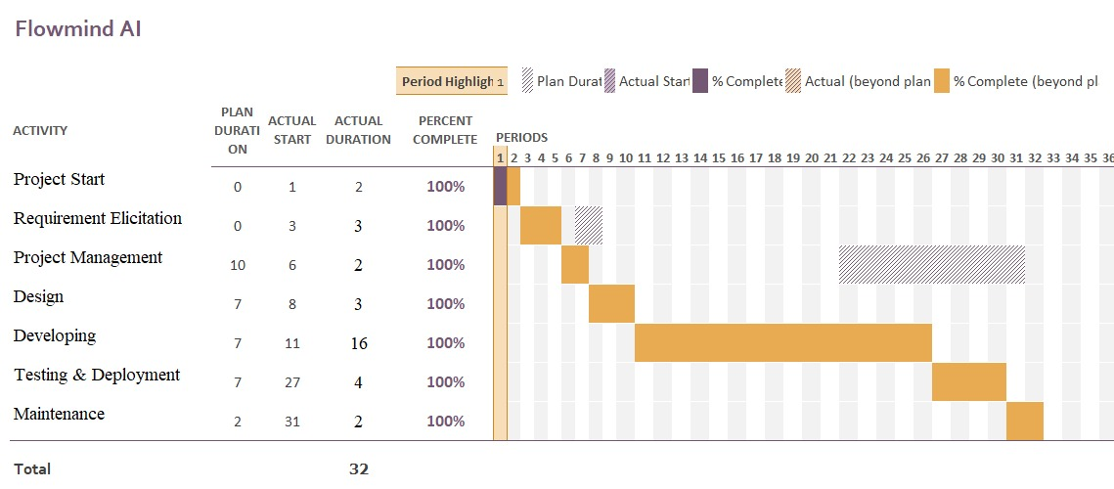

References
- Jeong, A. C. (2020). Developing computer-aided diagramming tools to mine, model and support students’ reasoning processes. Educational Technology Research and Development, 68(6), 3353-3369.
- Lee, S., Murphy, G. C., Fritz, T., & Allen, M. (2008, September). How can diagramming tools help support programming activities?. In 2008 IEEE Symposium on Visual Languages and Human-Centric Computing (pp. 246-249). IEEE.
- Cao, S., Grundy, J. C., Hosking, J. G., Stoeckle, H., Tempero, E. D., & Zhu, N. (2005, January). Generating Web-based User Interfaces for Diagramming Tools. In AUIC (pp. 63-72).
- Wang, D. (2007). Diagramming design research. Journal of Interior Design, 33(1), 33-43.
- Eng, N. L., Bracewell, R. H., & Clarkson, P. J. (2009, January). Concept diagramming software for engineering design support: a review and synthesis of studies. In International Design Engineering Technical Conferences and Computers and Information in Engineering Conference (Vol. 49057, pp. 1221-1234).
- Priest, G., De Toffoli, S., & Findlen, P. (2018). Tools of reason: The practice of scientific diagramming from antiquity to the present.
- Allmendinger, L. (1994). Diagrams and design tools in context. ACM SIGDOC Asterisk Journal of Computer Documentation, 18(4), 25-41.
Appendix A: Glossary

Appendix A: Glossary
Below is the glossary of terms and acronyms relevant to the FlowMind AI Diagram Generator project. These terms will help in understanding the specific concepts, technologies, and functions used throughout the Software Requirements Specification (SRS).

Acronyms and Abbreviations
- API: Application Programming Interface
A set of functions that allows different software systems to communicate with each other.
- CSS: Cascading Style Sheets
A style sheet language used for describing the presentation of a web page written in HTML or XML.
- DFD: Data Flow Diagram
A diagram that represents the flow of data within a system, illustrating how input is processed into output.
- HTML: HyperText Markup Language
The standard markup language used to create web pages.
- JS: JavaScript
A programming language used to create interactive effects within web browsers.
- PNG: Portable Network Graphics
A raster graphics file format that supports lossless data compression.
- PDF: Portable Document Format
A file format developed by Adobe used to present documents, including text formatting and images, independently of software, hardware, or operating systems.
- React.js: A JavaScript library for building user interfaces, particularly for single-page applications where you need a fast, interactive user experience..
- UI: User Interface
The means by which a user interacts with a system, including displays, controls, and visual elements.
- UML: Unified Modeling Language
A standard way to visualize the design of a system using various diagrams such as use case, sequence, class, and activity diagrams.

Terms
- Diagram Types
The types of system models generated by the FlowMind AI Diagram Generator, including:
  - Flowchart: A diagram representing a process or workflow.
  - Use Case Diagram: A diagram showing interactions between users (actors) and the system.
  - Sequence Diagram: A diagram illustrating the sequence of interactions between components or actors.
  - Data Flow Diagram (DFD): A diagram showing how data moves within a system, typically representing processes and their interactions.
- Diagram Generation
The process of creating a visual representation (e.g., flowchart, use case diagram) from structured user input using predefined templates.
- Customization
The process of editing and adjusting a generated diagram, such as modifying nodes, labels, or connections.
- Export
The functionality that allows users to download a generated diagram in various formats, such as PNG or PDF, for use in reports or presentations.
- Mobile-Responsive
A design approach where the application is optimized to provide a seamless experience on both desktop and mobile devices, adjusting the layout to fit different screen sizes.
- User Authentication
The process of verifying the identity of a user, typically involving login credentials (email and password).
- Frontend Development
The part of the application development that focuses on the user interface and experience, typically involving technologies like HTML, CSS, and JavaScript.
- Backend Development
The part of the application development that focuses on the server-side logic, databases, and APIs, typically involving technologies like Node.js or Python.
- Export Formats
The file formats available for users to download their generated diagrams, such as PNG, PDF, or potentially other formats in future releases.
- Cloud Storage
A service that allows users to store their diagrams and data remotely, making them accessible from any device with internet connectivity.

The FlowMind AI Diagram Generator project and ensure clarity in interpreting the Software Requirements Specification (SRS).
Appendix B: IV & V Report
(Independent verification & validation) IV & V Resource

The Independent Verification and Validation (IV & V) process is critical to ensuring the accuracy, reliability, and completeness of the FlowMind AI Diagram Generator before its final release. IV & V is conducted by a separate team (or third party) from the development team to ensure that the system meets all the specified requirements, adheres to quality standards, and functions as expected in various environments.
The IV & V process is divided into Verification and Validation:

1. Verification Process
Verification ensures that the system is being built correctly according to the requirements and design specifications. This step checks that the product conforms to the defined architecture and meets functional specifications.
Verification Activities:
- Requirements Review
  - Verify that the Software Requirements Specification (SRS) is complete and well-defined.
  - Ensure that the functional and non-functional requirements are clear and achievable.
- Design Review
  - Review the system’s design documents (including system architecture, data flow, and class diagrams) to verify that the design aligns with the requirements.
- Code Inspection
  - Perform static analysis of the code to ensure adherence to coding standards, detect defects early, and ensure security practices are followed.
- Unit Testing
  - Verify that individual components of the system (e.g., diagram generation, export functionality) perform as expected in isolation.
- Integration Testing
  - Ensure that the various modules and components of the system (e.g., frontend and backend) work together as expected.
- System Testing
  - Verify that the complete system behaves as intended when all components are integrated. Test for performance, security, and compatibility.

2. Validation Process
Validation ensures that the system meets the user’s needs and expectations. It verifies that the right product is being built by comparing it against user requirements, real-world scenarios, and actual user behavior.
- Validation Activities:
- User Acceptance Testing (UAT)
- Conduct testing with end-users to ensure that the system meets their needs and is user-friendly.
- Check for usability issues and ensure that the system functions in a way that is consistent with user expectations.
- Functional Testing
  - Verify that all functional requirements are implemented correctly (e.g., creating diagrams, customizing diagrams, exporting files).
  - Test edge cases and scenarios that users may encounter.
- Performance Testing
  - Validate the system’s performance by testing how well the tool handles multiple users and large diagrams under varying loads.
- Security and Privacy Testing
  - Ensure that the system adheres to security and privacy policies, including secure user authentication, data encryption, and data protection.
  - Conduct penetration testing to identify vulnerabilities in the system.
- Compliance Testing
Verify compliance with relevant data protection regulations (e.g., GDPR, CCPA) to ensure that user data is handled securely and ethically.
- Cross-Platform Testing
- Validate that the system works across different operating systems (Windows, macOS, Linux) and mobile devices (Android, iOS).
  - Test compatibility across major web browsers (Chrome, Firefox, Safari, Edge).

IV & V Resources

The following resources are required to support the IV & V process for the FlowMind AI Diagram Generator project:
- Testers: Independent testers with expertise in software quality assurance, system integration, and user experience.
- Testing Tools:
  - Selenium for automated UI testing.
  - JMeter for performance testing.
  - Burp Suite for security testing and vulnerability scanning.
- Test Environments:
  - Test environments that mimic production systems, including various web browsers, operating systems, and mobile devices.
- User Feedback: Access to a diverse group of end-users for User Acceptance Testing (UAT) and usability testing.
- Compliance and Security Experts: Professionals to ensure that the system meets legal and security standards.
- Documentation: Detailed test plans, test cases, and test reports documenting the verification and validation process.

4. IV & V Deliverables
The deliverables from the IV & V process include:
- Verification & Validation Test Plan: A document outlining the IV & V process, test cases, testing criteria, and timelines.
- Test Reports: Reports on the outcome of all verification and validation tests, including any issues found and their resolution.
- Defect Tracking Report: A document that tracks defects identified during testing, their severity, and the corrective actions taken.
- Final IV & V Summary Report: A comprehensive report summarizing the verification and validation process, the effectiveness of the testing, and the final quality assessment of the system.

Name Signature

S# | Defect Description | Origin Stage | Status | Fix Time
 |  |  |  | Hours | Minutes
1
2
3
…
Table 3: List of non-trivial defects

